**Certificate of Completion**

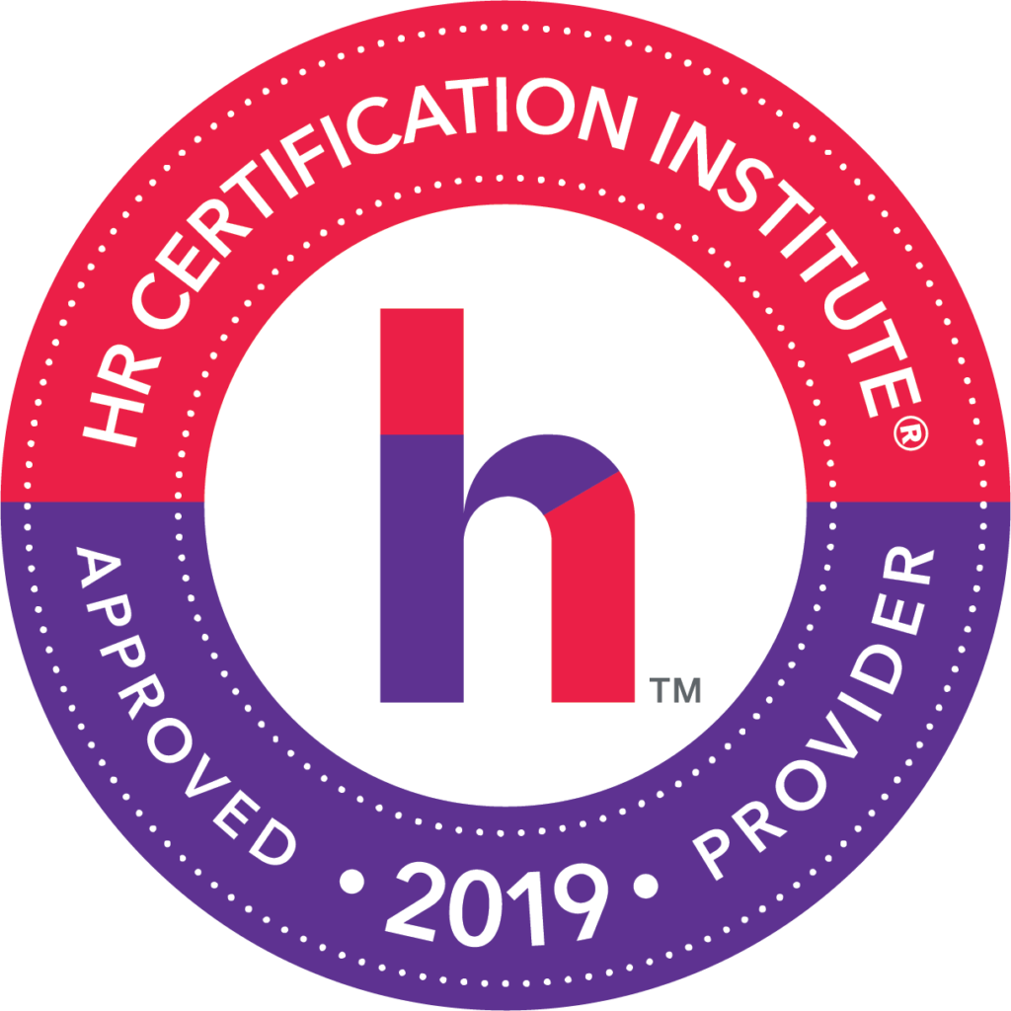

**Untangling The Ever Expanding Leave Law Mess**

**Speakers: Armando Riccio, Esq – Alan Dean – David Woolf, Esq – Carol Asselta – Brooke Razer**

**June 12, 2019**

*Participant attended SHRM Chapter #260 seminar and received:*

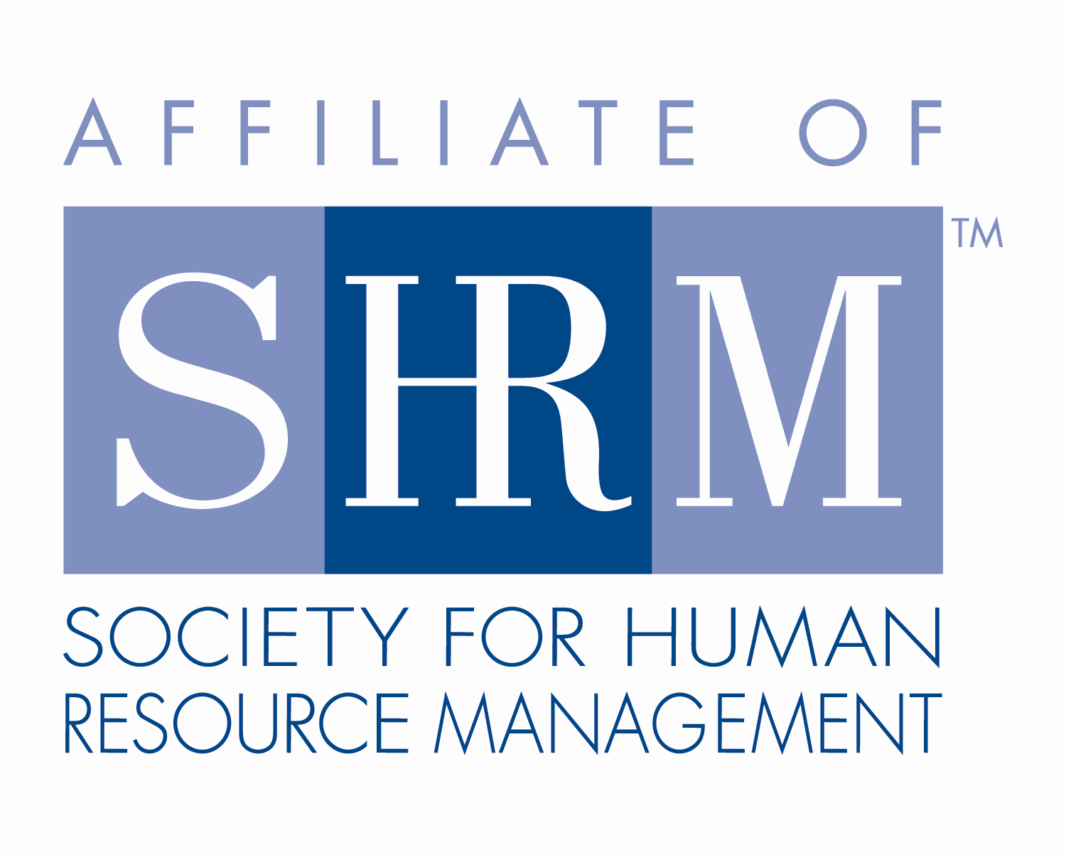

**7.00 Credit Hours**

This program, ID # 387219 has been approved for 7.00 (General) recertification credit hours toward PHR, SPHR and GPHR recertification through the HR Certification Institute. Please be sure to note the program ID number on your recertification application form. For more information about certification or recertification, please visit the HR Certification Institute website at [www.hrci.org](http://www.hrci.org).

**Certificate of Completion**

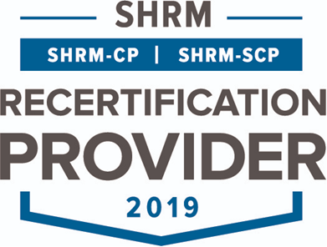

**Untangling The Ever Expanding Leave Law Mess**

**Speakers: Armando Riccio, Esq – Alan Dean – David Woolf, Esq – Carol Asselta – Brooke Razer**

**June 12, 2019**

*Participant attended SHRM Chapter #260 seminar and received:*



**7.00 PDCs**

This program, ACTIVITY 19-YF3A7 has been approved for 7.00 PDCs toward SHRM-CP and SHRM-SCP recertification through the Society of Human Resource Management. Please be sure to note the activity ID number on your recertification application form. For more information about certification or recertification, please visit the HR Certification Institute website at [www.shrm.org/certification](http://www.shrm.org/certification).