**Dinner Meeting Dates/Topics**

Meetings are held at the

Ramada Inn, Vineland NJ

Social Time - 5:30pm / Meeting 6:15pm - 8:30 pm

**Thursday, September 19, 2024**

## Transform Your HR Department into a Profit Center

## Thursday, October 17, 2024

## Collaborative Problem Solving

**Thursday, November 21, 2024**

From EI to AI

**Holiday Social – TBD**

**Thursday, January 16, 2025**

Mastering Difficult Conversations

**Thursday, February 20, 2025**

Stop Managing Change & Start Leading Transformation

**Thursday, March 20, 2025**

Teaching HR Professionals to Advocate

**Thursday, April 17, 2025**

Age Appropriate: Create a multi-generational workforce

**Thursday, May 15, 2025**

TBD

**Thursday, June 19, 2025**

Storytelling Through Data Integrity & Data Visualization

**Breakfast Roundtables— Hampton Inn**

* **Tuesday, Dec. 10, 2024 -** Employee Handbooks

## Tuesday, Jan. 21 - An Eye for AI: Optimizing

* **Tuesday, May 21, 2025 – Positive Intelligence**

**Lunch & Learns – noon to 1:00 PM - Free for members**

## Nov 11, 2024 - Harnessing AI in Human Resources

* **Jan, 2025 –** TBD
* **April, 2025 –** TBD
* **June, 2025 -** TBD

**SEMINAR May/June TBD**

**2024 - 2025 Officers**

**  
Kim Kerrigan, SPHR;SHRM-SCP

**Vice President** 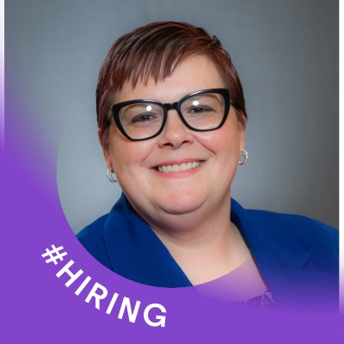

Karen Rivers: SHRM-CP

**Recording Secretary** 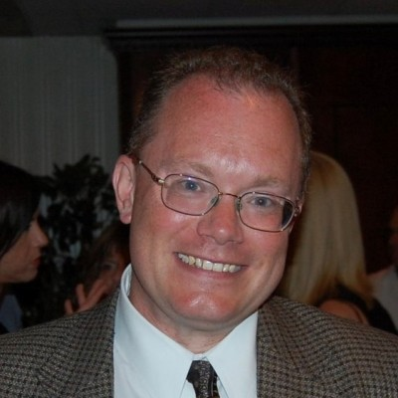  
Bruce Dutra; SPHR

**

Kim Cruz,PHR

**C:\Users\carol\Documents\HRA\Brochure\wendy .jpg**

**Serving HR Professionals for over 70 years.**

**HRA OF SOUTHERN NEW JERSEY  
PO Box 388**

**Vineland, NJ 08362**

**BENEFITS OF HRA MEMBERSHIP**

* Monthly Dinner Discount
* PHR/SPHR Recertification Credits
* SHRM-SCP and SHRM-CP - PDCs
* Seminar Discounts
* Breakfast Roundtable Discounts
* Legal Updates
* Wage & Benefit Survey
* In-Transition Group
* Study Group
* Book Club
* Professional Networking
* Virtual Lunch & Learns

**Annual Membership**

National SHRM Member –

* Designate HRA as your chapter of choice – **FREE**
* Non-designated $25 year

Not a National SHRM Member –

* $50 / calendar year

**TO JOIN OR RENEW GO TO:**

http://hrasnj.shrm.org/chapter-application-new-member

**Email:** [**hrasnj@gmail.com**](mailto:hrasnj@gmail.com)

**Website: http://hrasnj.shrm.org**

**HRA provides you opportunities to meet and build relationships with HR professionals in your community!**

**Committees/Opportunities:**

* College Relations / Scholarship
  + C Asselta / J Knoop
* Communications/Publicity
  + J Hammerstedt / J Skwara
* Community Outreach
  + Open
* Diversity
  + Open
* Emerging Professionals
  + P Koch / S Gandy
* Legal Update
  + M Balne, Esq
* Member Experience
  + A Trummer
* Membership
  + C Asselta / B DuBois
* Professional Development
  + C Asselta
* Scholarships / Awards
  + Open
* Programs
  + B Dutra
* SHRM Liasion
  + Laura Powers
* Sponsorships
  + T Brophy
* Workforce Readiness
  + J Knoop / D McCullough

**Who We Are**

The Human Resource Association of Southern New Jersey serves a five-county region from Vineland, NJ. Located in the “Garden Spot” of the “Garden State” we serve professionals and businesses throughout Cumberland, Salem, Gloucester, Atlantic and Cape May Counties.

For over 70 years, we have focused on serving the professional and advancing the profession of Human Capital Management as an affiliate of SHRM. Our membership of 300+ is a diverse group of passionate individuals encompassing seasoned and entry-level Human Resources professionals, professionals in smaller organizations handed the responsibility of human resource management, and an active vendor population touching every aspect of human resources.

Our Member Value Proposition statement has, and continues to be, the reason we attract and maintain membership over their career. We are committed to serving our members with a balanced approach that encompasses professional development, personal development, staying connected, and providing opportunities to give back to the communities where we live and work. We deliver this value proposition through our dedicated members who take on voluntary leadership roles to serve the professional and advance the profession.

We have a strong heritage and a bright future because of our member-driven focus. We feel there is something for everyone in our chapter whether you are looking to attend a monthly meeting or to get involved in a voluntary leadership role. We look forward to welcoming you and getting acquainted at an upcoming chapter function.

**Our Values**

**Visit us On**

**http://hrasnj.shrm.org**



<https://www.facebook.com/HRASNJ>

https://www.linkedin.com/groups/HRA-Southern-New-Jersey-2948881