**Certificate of Completion**

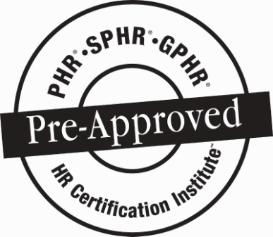

***“Building Your Talent Pipeline”***

**Speaker:** Doug Duncan, Talent Value

John Marcelliano, Talent Management Solutions

**Date: February 24, 2016**

*Participant attended SHRM Chapter 260 brealfast roundtable and received:*

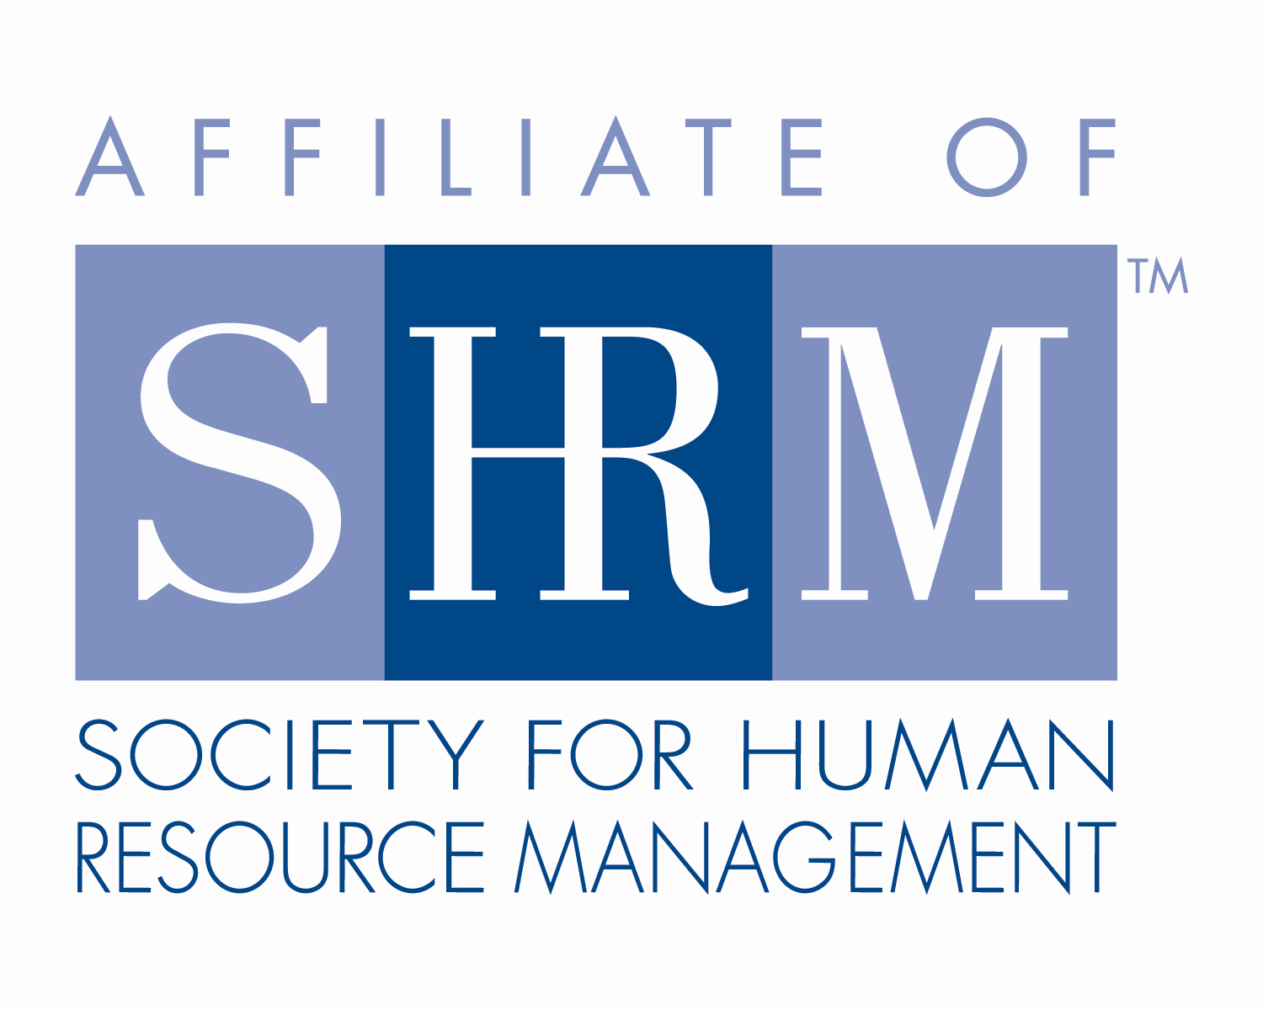

**2.50 Credit Hours**

This program, ID #271119 , “Building Your Talent Pipeline” has been approved for 2.50 (Business/Strategic) recertification credit hours toward PHR, SPHR and GPHR recertification through the HR Certification Institute. Please be sure to note the program ID number on your recertification application form. For more information about certification or recertification, please visit the HR Certification Institute website at [www.hrci.org](http://www.hrci.org).

**Certificate of Completion**

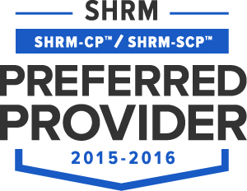

***“Building Your Talent Pipeline”***

**Speaker:** Doug Duncan, Talent Value

John Marcelliano, Talent Management Solutions

**Date: February 24, 2016**

*Participant attended SHRM Chapter 260 breakfast roundtable and received:*

**2.50 PDCs (Professional Development Credits)**



This program, ACTIVITY ID# 16-IGFZN, “Building Your Talent Pipeline” has been approved for 2.50 PDCs toward SHRM-CP and SHRM-SCP recertification through the Society of Human Resource Management. Please be sure to note the activity ID number on your recertification application form. For more information about certification or recertification, please visit the HR Certification Institute website at [www.shrm.org/certification](http://www.shrm.org/certification).