**Certificate of Completion**

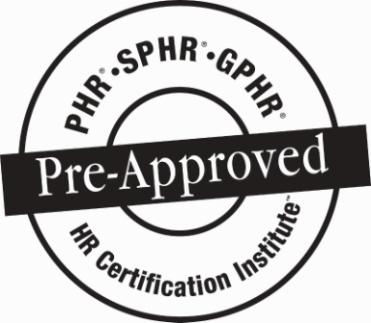

***SOCIAL MEDIA IN THE WORKPLACE:***

***LEGAL TRENDS AND ETHICAL CONSIDER***

**Speakers: Melissa Salimbene and**

**Lindsay Dischleybe**

**Chiesa Shahinian & Giantomasi**

**Date: June 15, 2017(use 5/19/17 when filing re-certification – speaker switched date)**

*Participant attended SHRM Chapter 260 dinner meeting and received:*

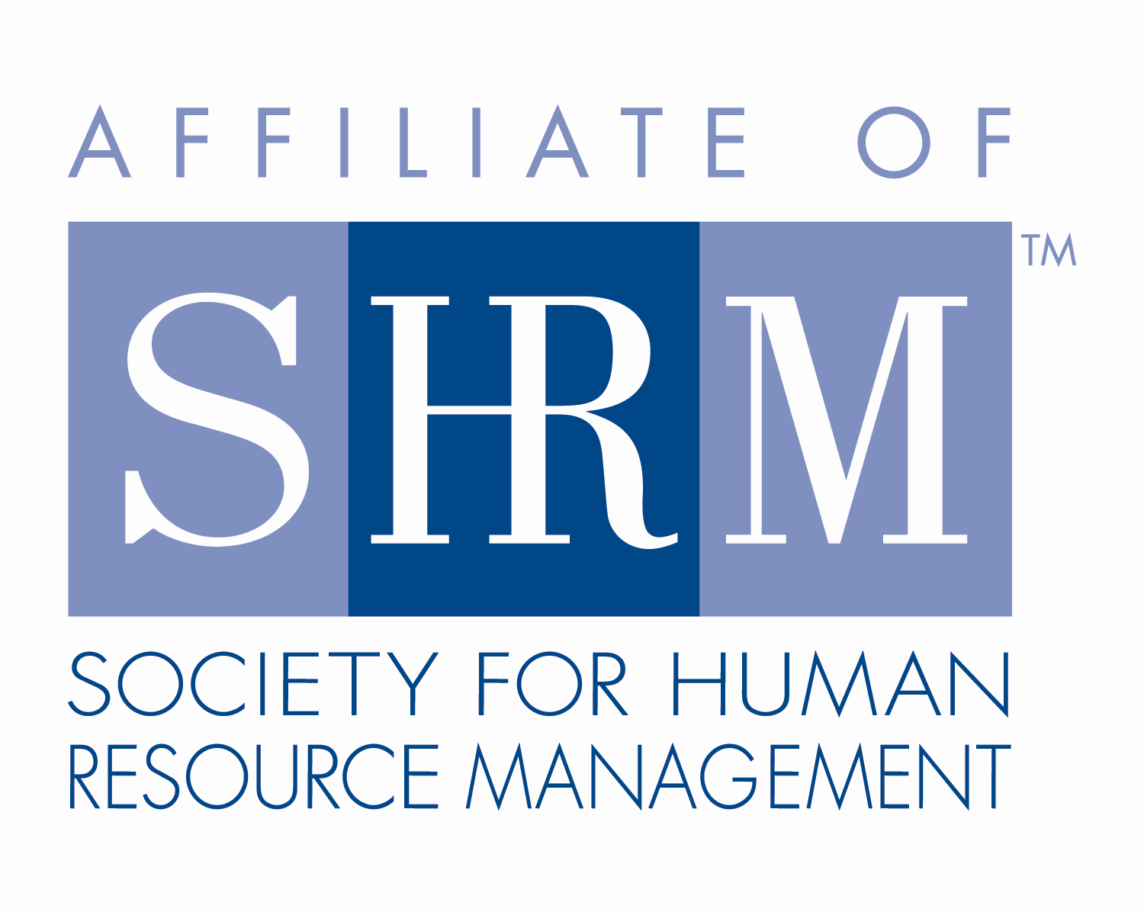

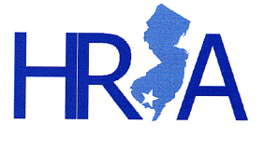**1.25 Credit Hours**

This program, ID # 294742, “Social Media in the Workplace: Legal Trends and Ethical Consider” has been approved for 1.25 (General) recertification credit hours toward PHR, SPHR and GPHR recertification through the HR Certification Institute. Please be sure to note the program ID number on your recertification application form. For more information about certification or recertification, please visit the HR Certification Institute website at [www.hrci.org](http://www.hrci.org).

**Certificate of Completion**

C:\Users\BoateA\Desktop\HRA SNJ\SHRM SEAL-Preferred Provider Recert_PANTONE 100K_2016_1.25in (®).tiff

***SOCIAL MEDIA IN THE WORKPLACE:***

***LEGAL TRENDS AND EHTICAL CONSIDER***

**Speakers: Melissa Salimbene and**

**Lindsay Dischleybe**

**Chiesa Shahinian & Giantomasi**

**Date: June 15, 2017(use 6/15/17 when filing re-certification – speaker switched date)**

*Participant attended SHRM Chapter 260 dinner meeting and received:*

**1.25 PDCs (Professional Development Credits)**



This program, ACTIVITY ID#17-OC9YB, “Social Media in the Workplace: Legal Trends and Ethical Consider” has been approved for 1.25 PDCs toward SHRM-CP and SHRM-SCP recertification through the Society of Human Resource Management. Please be sure to note the activity ID number on your recertification application form. For more information about certification or recertification, please visit the HR Certification Institute website at [www.shrm.org/certification](http://www.shrm.org/certification).