**Certificate of Completion**

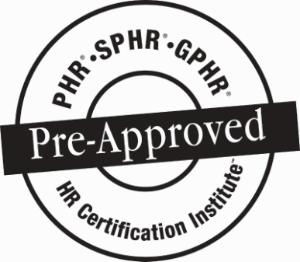

How Performance Management is Killing Performance — and What to Do About It.

**Speakers: M Tamra Chandler**

**Date: January 24, 2017**

*Participant attended SHRM Chapter 260 Breakfast Roundtable:*

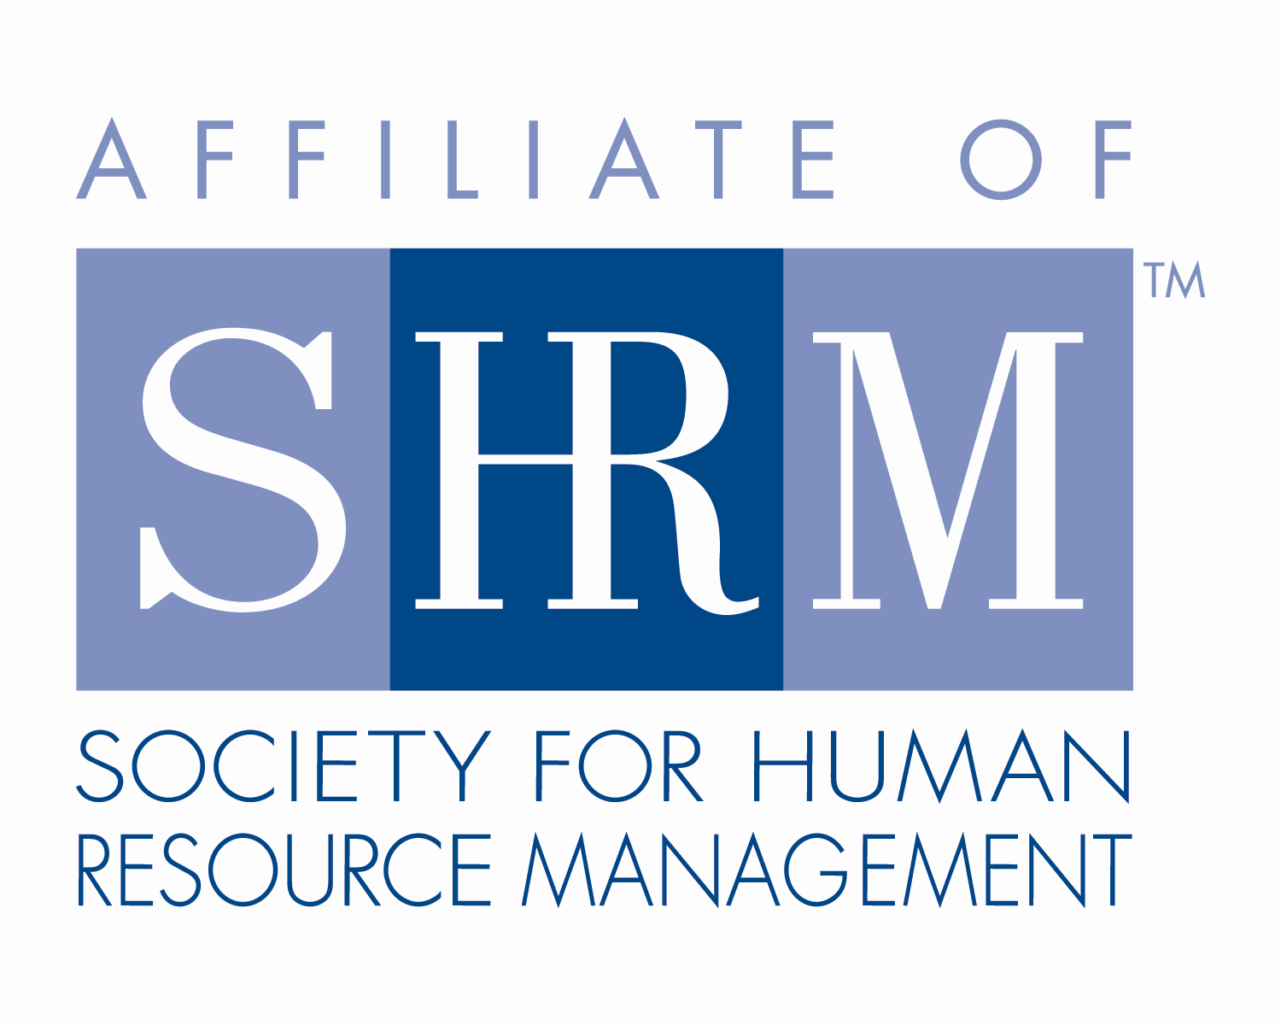

**2.50 Credit Hours**

This program, ID #299097 , “How Performance Management is Killing Performance – and What to Do About it” has been approved for 2.5 (General) recertification credit hours toward PHR, SPHR and GPHR recertification through the HR Certification Institute. Please be sure to note the program ID number on your recertification application form. For more information about certification or recertification, please visit the HR Certification Institute website at [www.hrci.org](http://www.hrci.org).

**Certificate of Completion**

C:\Users\BoateA\Desktop\HRA SNJ\SHRM SEAL-Preferred Provider Recert_PANTONE 100K_2016_1.25in (®).tiff

How Performance Management is Killing Performance — and What to Do About It.

**Speakers: M Tamra Chandler**

**Date: January 24, 2017**

*Participant attended SHRM Chapter 260 Breakfast Roundtable:*

**2.5 PDCs (Professional Development Credits)**



This program, ACTIVITY ID# 17-QW3O5, “How Performance Management is Killing Performance – and What to Do About it”has been approved for 2.5 PDCs toward SHRM-CP and SHRM-SCP recertification through the Society of Human Resource Management. Please be sure to note the activity ID number on your recertification application form. For more information about certification or recertification, please visit the HR Certification Institute website at [www.shrm.org/certification](http://www.shrm.org/certification).