**Certificate of Completion**



***Implications of Employment Relations***

**Speakers: Janette Levey Frisch**

**The EmpLAWyerologist Firm**

**Date: February 16, 2017**

*Participant attended SHRM Chapter 260 dinner meeting and received:*

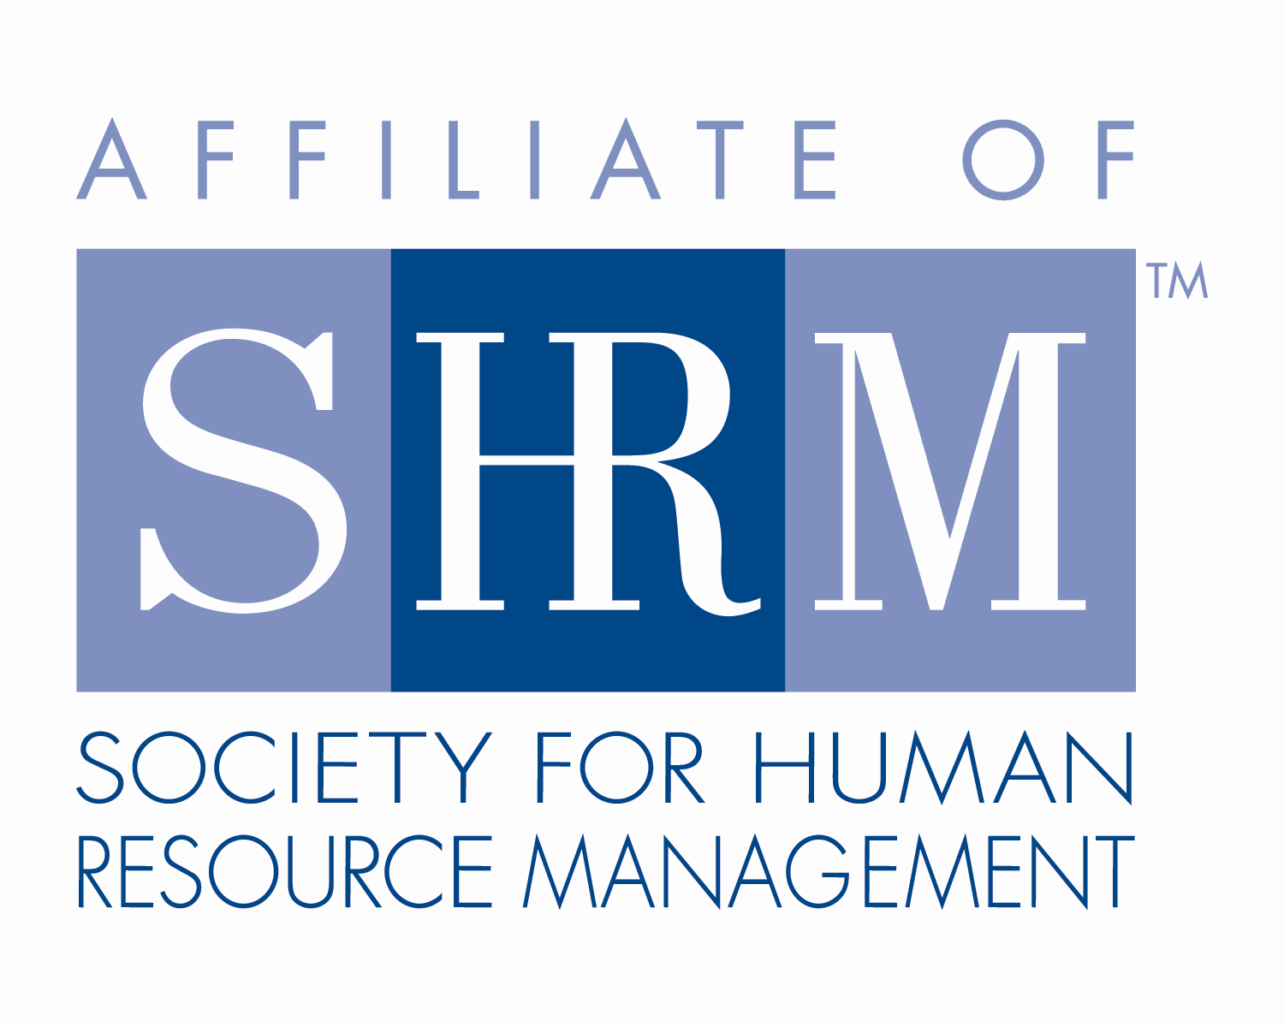

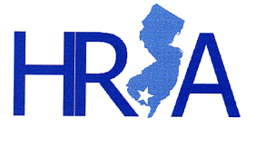**1.25 Credit Hours**

This program, ID # 294731, “Implications of Employment Relations” has been approved for 1.25 (General) recertification credit hours toward PHR, SPHR and GPHR recertification through the HR Certification Institute. Please be sure to note the program ID number on your recertification application form. For more information about certification or recertification, please visit the HR Certification Institute website at [www.hrci.org](http://www.hrci.org).

**Certificate of Completion**

C:\Users\BoateA\Desktop\HRA SNJ\SHRM SEAL-Preferred Provider Recert_PANTONE 100K_2016_1.25in (®).tiff

***Implications of Employment Relations***

**Speakers: Janette Levey Frisch**

**The EmpLAWyerologist Firm**

**Date: February 16, 2017**

*Participant attended SHRM Chapter 260 dinner meeting and received:*

**1.25 PDCs (Professional Development Credits)**



This program, ACTIVITY ID# 17-4P5DP, “Implications of Employment Relations” has been approved for 1.25 PDCs toward SHRM-CP and SHRM-SCP recertification through the Society of Human Resource Management. Please be sure to note the activity ID number on your recertification application form. For more information about certification or recertification, please visit the HR Certification Institute website at [www.shrm.org/certification](http://www.shrm.org/certification).