**Certificate of Completion**

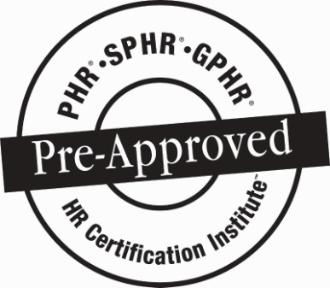

NJ Paid Sick Leave and Diane B Allen Equal Pay Laws

**Speakers: Asselta, Knoop & Riccio**

**Date: June 26 and July 11, 2018**

*Participant attended SHRM Chapter 260 Breakfast Roundtable:*

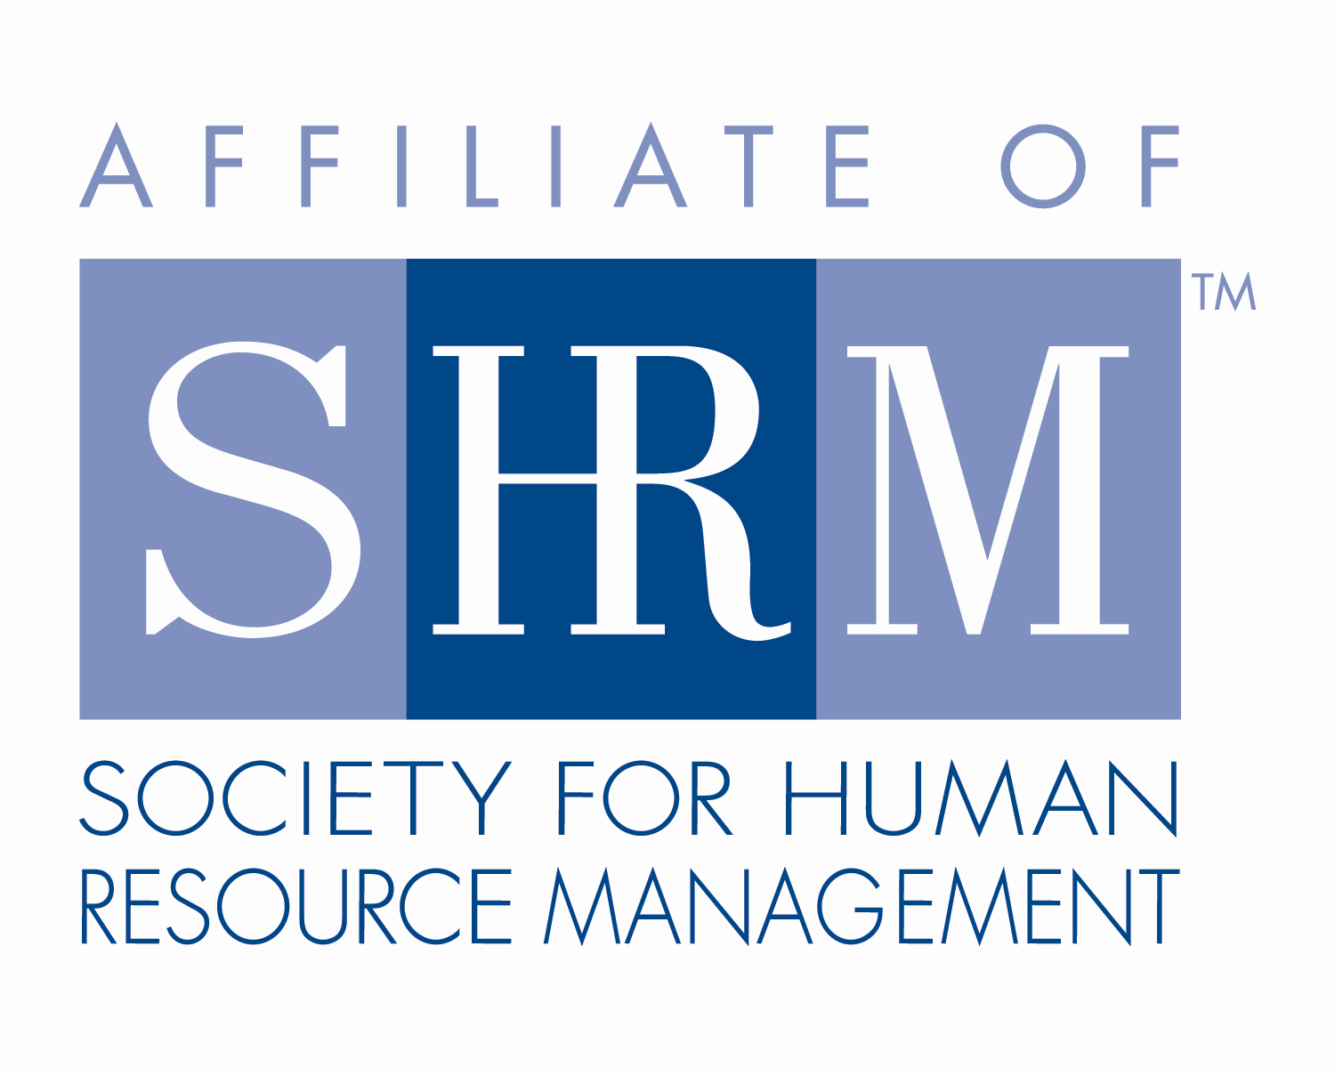

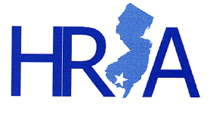**2.50 Credit Hours**

This program, ID #355337, “NJ Paid Sick Leave and Diane B Allen Equal Pay Laws” has been approved for 2.5 (General) recertification credit hours toward PHR, SPHR and GPHR recertification through the HR Certification Institute. Please be sure to note the program ID number on your recertification application form. For more information about certification or recertification, please visit the HR Certification Institute website at [www.hrci.org](http://www.hrci.org).

**Certificate of Completion**

C:\Users\BoateA\Desktop\HRA SNJ\SHRM SEAL-Preferred Provider Recert_PANTONE 100K_2016_1.25in (®).tiff

NJ Paid Sick Leave and Diane B Allen Equal Pay Laws

**Speakers: Asselta, Knoop & Riccio**

**Date: June 26 and July 11, 2018**

**(note – use 6/16/18 for the date when submitting)**

*Participant attended SHRM Chapter 260 Breakfast Roundtable:*

**2.5 PDCs (Professional Development Credits)**



This program, ACTIVITY ID# **18-1JXBA,** “NJ Paid Sick Leave and Diane B Allen Equal Pay Laws” has been approved for 2.5 PDCs toward SHRM-CP and SHRM-SCP recertification through the Society of Human Resource Management. Please be sure to note the activity ID number on your recertification application form. For more information about certification or recertification, please visit the HR Certification Institute website at [www.shrm.org/certification](http://www.shrm.org/certification).