**Certificate of Completion**

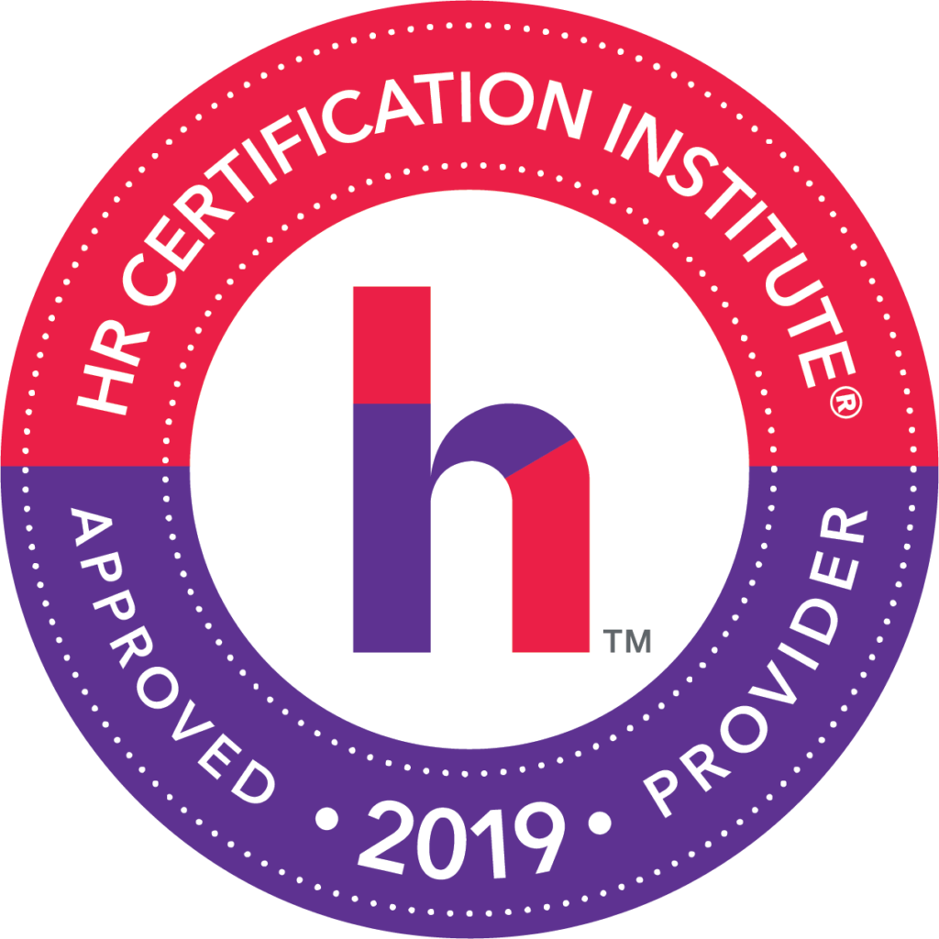

**Active Shooter**

**Speakers: Ed Moore and others**

**Date: Dec. 5, 2019**

*Participant attended SHRM Chapter 260*

*Breakfast Roundtable:*

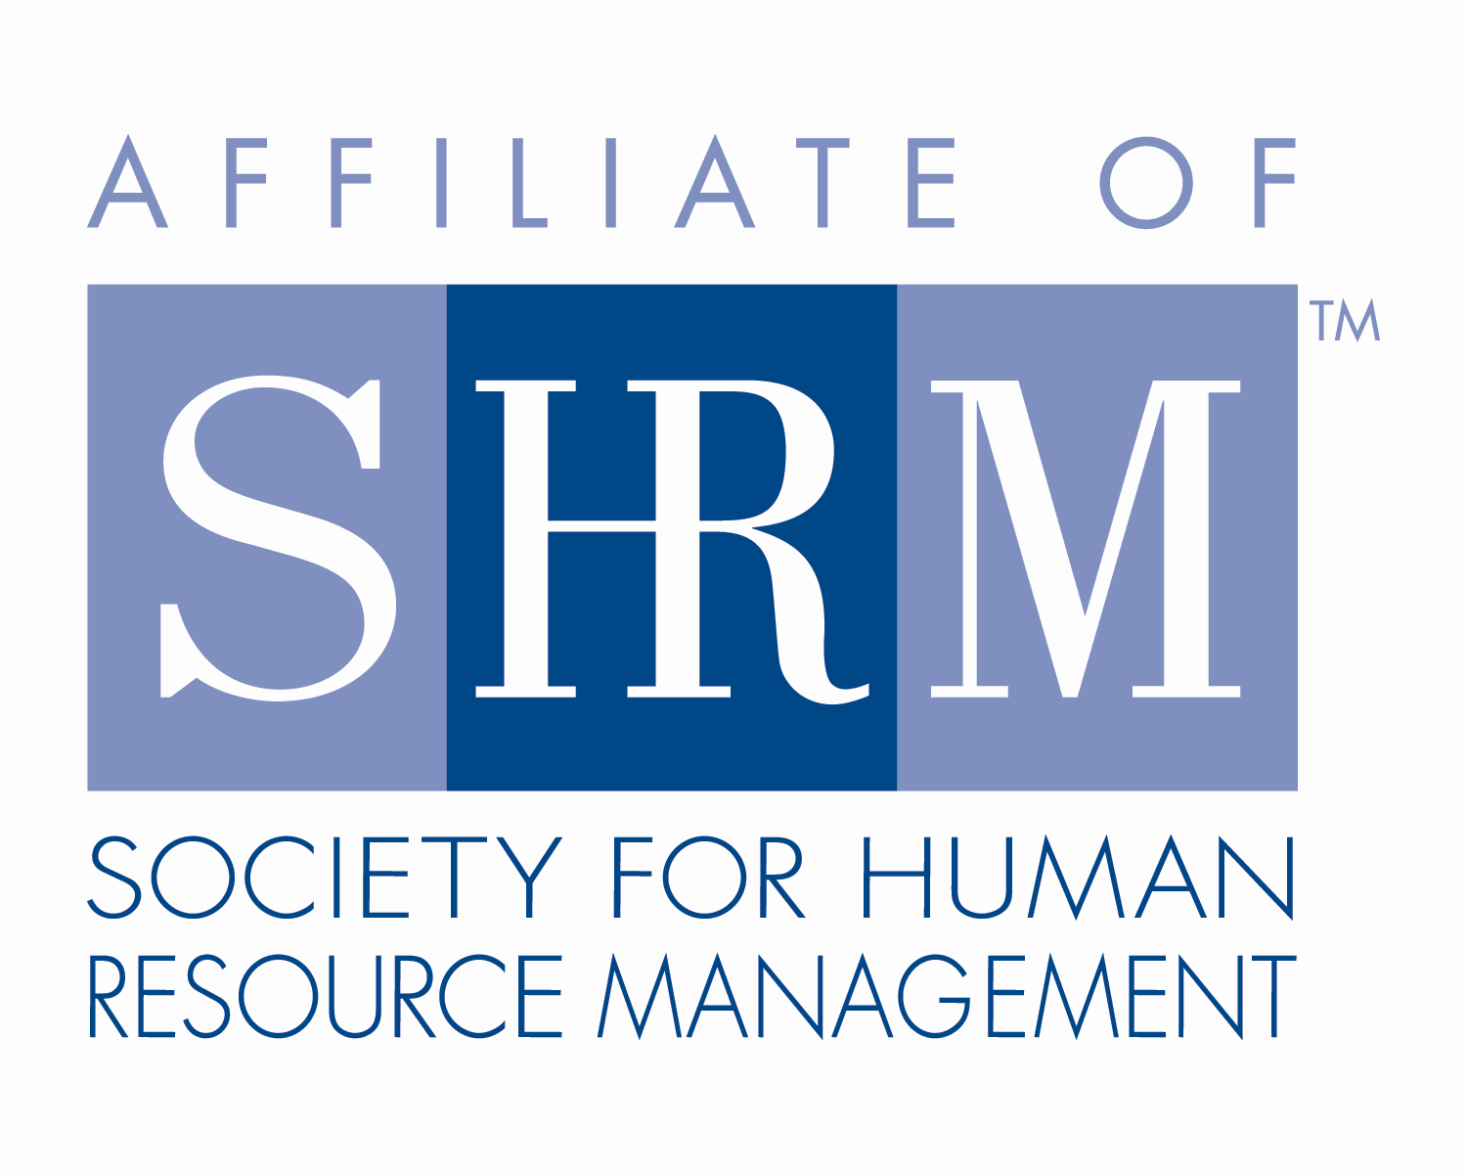

**2.50 Credit Hours**

## This program, ID # 401358, “Active Shooter” has been approved for 2.5 (General) recertification credit hours toward PHR, SPHR and GPHR recertification through the HR Certification Institute. Please be sure to note the program ID number on your recertification application form. For more information about certification or recertification, please visit the HR Certification Institute website at [www.hrci.org](http://www.hrci.org).

**Certificate of Completion**

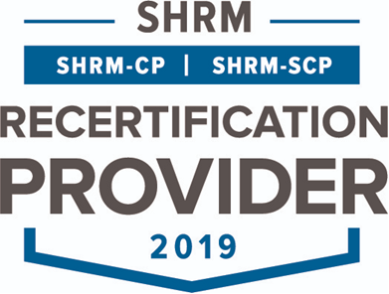

**Active Shooter**

**Speakers: Ed Moore and others**

**Date: Dec. 5, 2019**

*Participant attended SHRM Chapter 260*

*Breakfast Roundtable:*

**2.5 PDCs (Professional Development Credits)**



This program, ACTIVITY ID# 19-A9HE6 “Active Shooter” has been approved for 2.5 PDCs toward SHRM-CP and SHRM-SCP recertification through the Society of Human Resource Management. Please be sure to note the activity ID number on your recertification application form. For more information about certification or recertification, please visit the HR Certification Institute website at [www.shrm.org/certification](http://www.shrm.org/certification).