**Certificate of Completion**



***ADAPTING TO CHANGE***

**Speakers: Anita Zinsmeister**

**Dale Carnegie Central and Southern NJ**

**Date: May 18, 2017 (use 6/15/17 when filing re-certification – speaker switched date)**

*Participant attended SHRM Chapter 260 dinner meeting and received:*

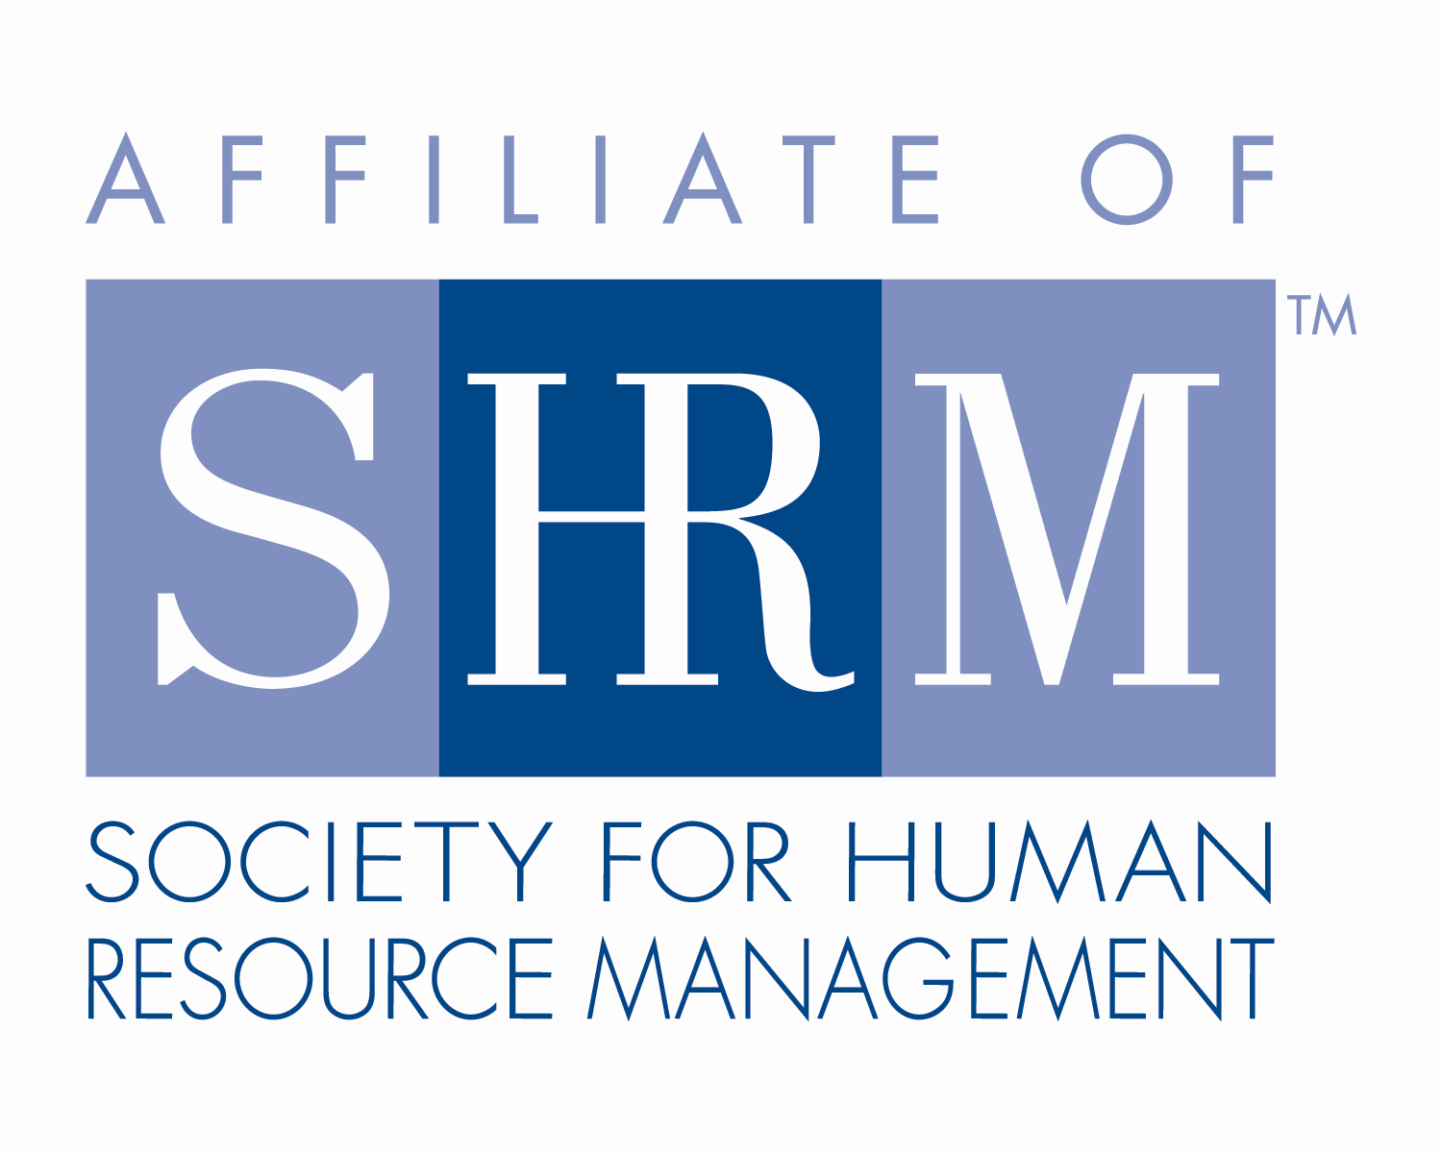

**1.25 Credit Hours**

This program, ID # 294744, “Adapting to Change” has been approved for 1.25 (Business) recertification credit hours toward PHR, SPHR and GPHR recertification through the HR Certification Institute. Please be sure to note the program ID number on your recertification application form. For more information about certification or recertification, please visit the HR Certification Institute website at [www.hrci.org](http://www.hrci.org).

**Certificate of Completion**

C:\Users\BoateA\Desktop\HRA SNJ\SHRM SEAL-Preferred Provider Recert_PANTONE 100K_2016_1.25in (®).tiff

***ADAPTING TO CHANGE***

**Speakers: Anita Zinsmeister**

**Dale Carnegie Central & Southern NJ**

**Date: May 18, 2017(use 6/15/17 when filing re-certification – speaker switched date)**

*Participant attended SHRM Chapter 260 dinner meeting and received:*

**1.25 PDCs (Professional Development Credits)**



This program, ACTIVITY ID# 17-OC9YB, “Adapting to Change” has been approved for 1.25 PDCs toward SHRM-CP and SHRM-SCP recertification through the Society of Human Resource Management. Please be sure to note the activity ID number on your recertification application form. For more information about certification or recertification, please visit the HR Certification Institute website at [www.shrm.org/certification](http://www.shrm.org/certification).