**Certificate of Completion**

***Legal Updates/Important Action***

**Speaker: Megan Knowlton Balne, Esq.**

**Date: August 14, 2023**

*Participant attended SHRM Chapter 260 webinar*

*and received:*

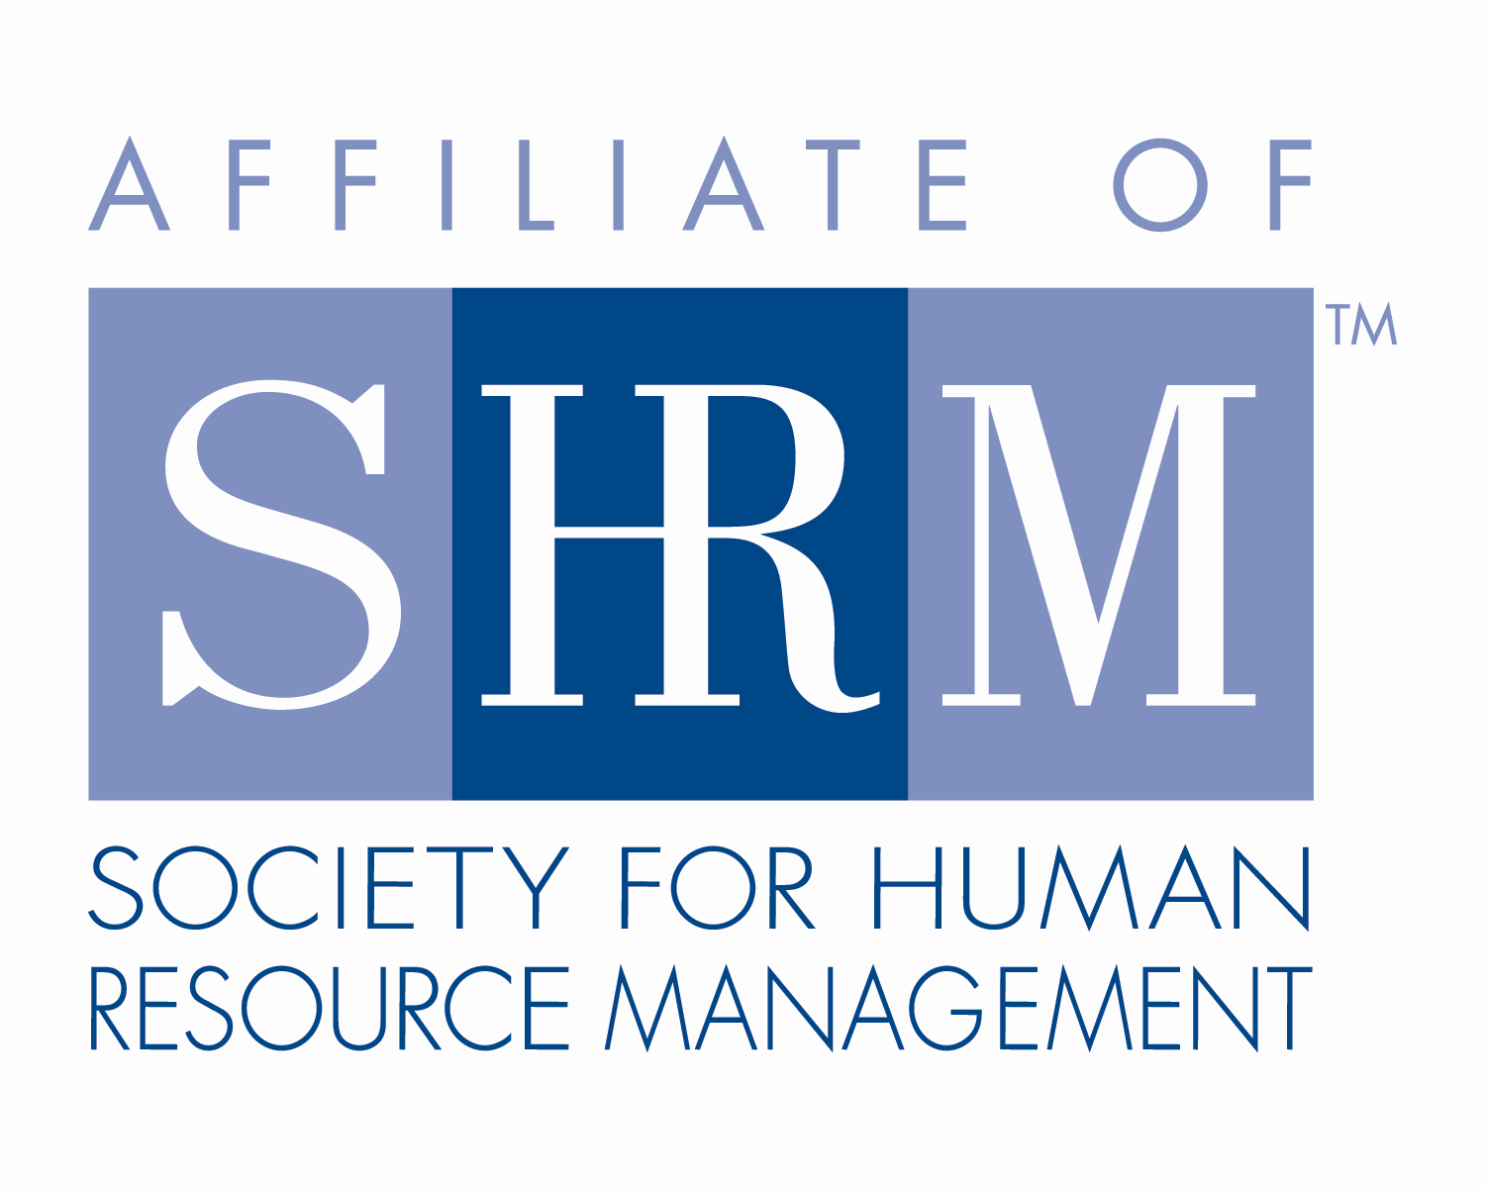

**1.0 Credit Hour**

This program, ID #639132 *Legal Updates/Important Action*, has been approved for 1.0 HR (General) recertification credit hour toward PHR, SPHR and GPHR recertification through the HR Certification Institute. Please be sure to note the program ID number on your recertification application form. For more information about certification or recertification, please visit the Human Resources Certification Institute website at [www.hrci.org](http://www.hrci.org).

**Certificate of Completion**

***Legal Updates/Important Action***

**Speaker: Megan Knowlton Balne, Esq.**

**Date: August 14, 2023**

*Participant attended SHRM Chapter 260 seminar*

*and received:*

**1.0 PDC (Professional Development Credit)**

This program, ACTIVITY 23-M5GVT *Legal Updates/Important Action*, has been approved for 1.0 PDC toward SHRM-CP and SHRM-SCP recertification through the Society of Human Resource Management. Please be sure to note the activity ID number on your recertification application form. For more information about certification or recertification, please visit the Society for Human Resource Management website at [www.shrm.org/certification](http://www.shrm.org/certification).