**Certificate of Completion**

***Flex: A Leader’s Guide to Staying Nimble***

***and Mastering Transformative Change***

**Speaker: Rick Grimaldi, Esq.**

**Date: January 20, 2022**

*Participant attended SHRM Chapter 260 meeting*

*and received:*

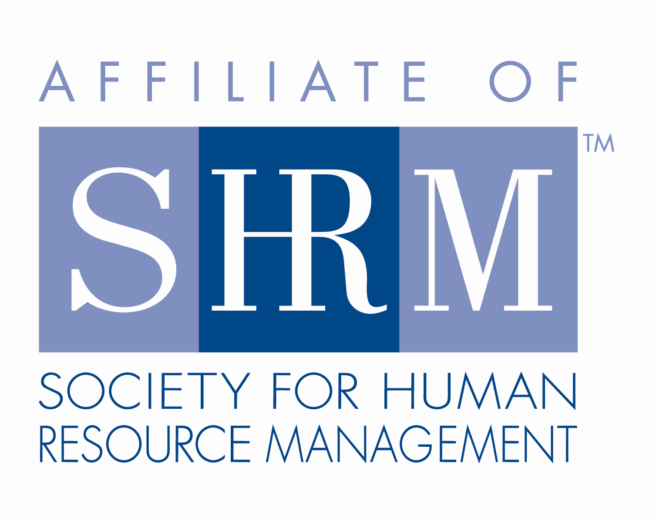

 **1.25 Credit Hours**

This program, ID #574211 *Flex: A Leader’s Guide to Staying Nimble and Mastering Transformative Change*, has been approved for 1.25 (General) recertification credit hours toward PHR, SPHR and GPHR recertification through the HR Certification Institute. Please be sure to note the program ID number on your recertification application form. For more information about certification or recertification, please visit the Human Resources Certification Institute website at [www.hrci.org](http://www.hrci.org).

**Certificate of Completion**

***Flex: A Leader’s Guide to Staying Nimble***

***and Mastering Transformative Change***

**Speaker: Rick Grimaldi, Esq.**

**Date: January 20, 2022**

*Participant attended SHRM Chapter 260 meeting*

*and received:*

**1.25 PDCs (Professional Development Credits)**



This program, ACTIVITY 22-9JGK2 *Flex: A Leader’s Guide to Staying Nimble and Mastering Transformative Change*, has been approved for 1.25 PDCs toward SHRM-CP and SHRM-SCP recertification through the Society of Human Resource Management. Please be sure to note the activity ID number on your recertification application form. For more information about certification or recertification, please visit the Society for Human Resource Management website at [www.shrm.org/certification](http://www.shrm.org/certification).