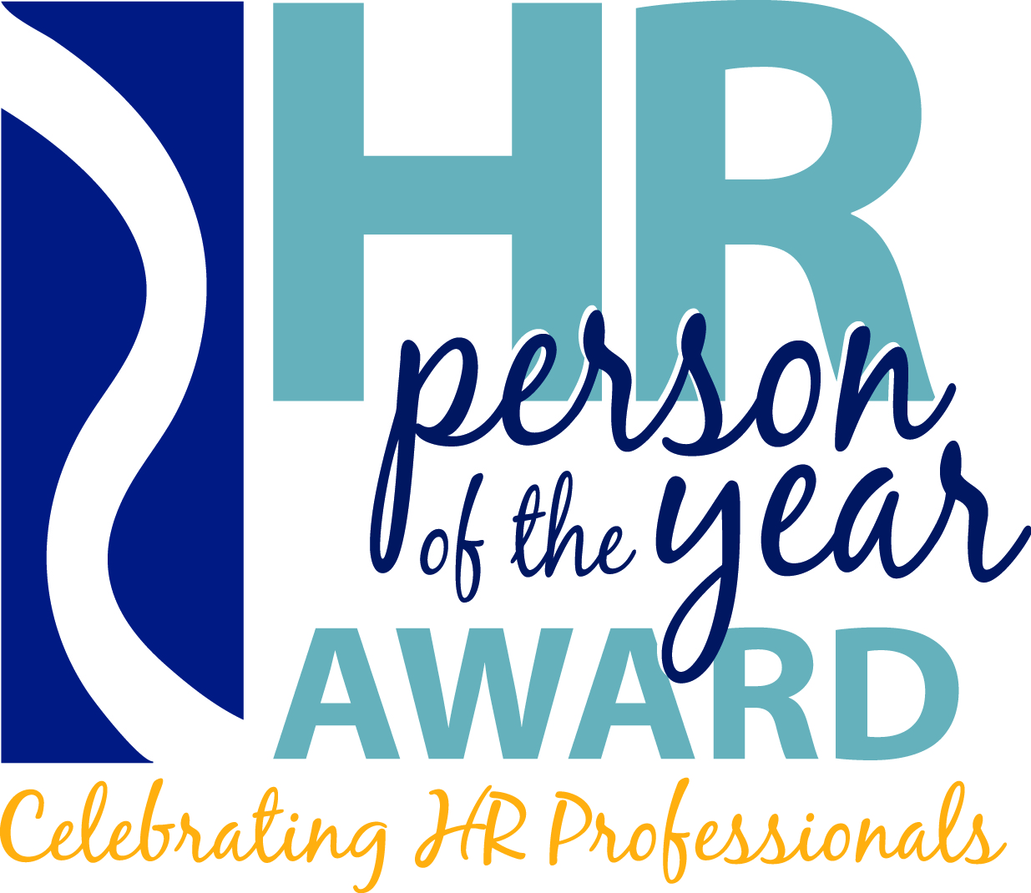

Delaware Valley HR Person of the Year 2015
E-mail Marketing Schedule and Copy
October 2014 – May 2015

Distribution Date: Subject:
October 15, 2014 (1) | 2015 HR Person of the Year Nominations are Open
November 12, 2014 (2) | Call for Nominations/Registration
December 17, 2014 (3) | Call for Nominations/Sponsorship/Registration
January 14, 2015 (4) | Call for Nominations/Sponsorship/Registration
February 4, 2015 (5) | Nominations/Registration/Sponsorship/Silent Auction
February 23, 2015 (6) | Last Call – Nominations close in 1 week
March 18, 2015 (7) | Registration Early Bird Deadline (March 31)/ Silent Auction
April 15, 2015 (8) | Registration/Sponsorship/Silent Auction
April 29, 2014 (9) | Registration Deadline (May 19)/Silent Auction
May 12, 2015 (10) | Registration Last Chance (1 week to deadline May 19)
May 28, 2015 (11) | Post-Event Thank You and Follow Up

Email #1 – October, 15, 2014
Subject Line: 2015 HR Person of the Year Nominations are Open

Hello,

Nominations are now open for the 15th Annual Delaware Valley HR Person of the Year Award!

The 2015 committee is seeking candidates who represent “the best” in the human resources management profession. Developed in 2001, this highly prestigious award recognizes outstanding individuals in the HR profession who exemplify outstanding achievement, creative approaches, and consistently high performance.

Nomination categories include:
- HR Person of the Year
- HR Consultant of the Year
- HR Rising Star of the Year

You could be the next HR Person of the Year, HR Consultant of the Year, or HR Rising Star of the Year!

Want to nominate yourself or a colleague for one of these prestigious awards? It’s easy! Just complete the simple Nomination Form and submit before the deadline on Friday, March 2, 2015.

NOMINATE A PROFESSIONAL NOW | ELIGIBILITY REQUIREMENTS

SAVE THE DATE
The 15th Annual HR Person of the Year Awards Dinner
Thursday, May 21, 2015 from 5:30pm to 9:00pm at Vie, Philadelphia, PA.

Visit www.HRPersonAward.org for more information on sponsorship opportunities and event details.

Connect to the Delaware Valley HR Person of the Year Awards on LinkedIn and Facebook now!

The Delaware Valley HR Person of the Year Award is a joint effort between HR Association of Southern New Jersey, Chester County Human Resource Association, Delaware County SHRM, Delaware SHRM, Greater Valley Forge HR Association, Philadelphia SHRM, Tri-State HR Management Association chapters of the Society for Human Resource Management (SHRM).

